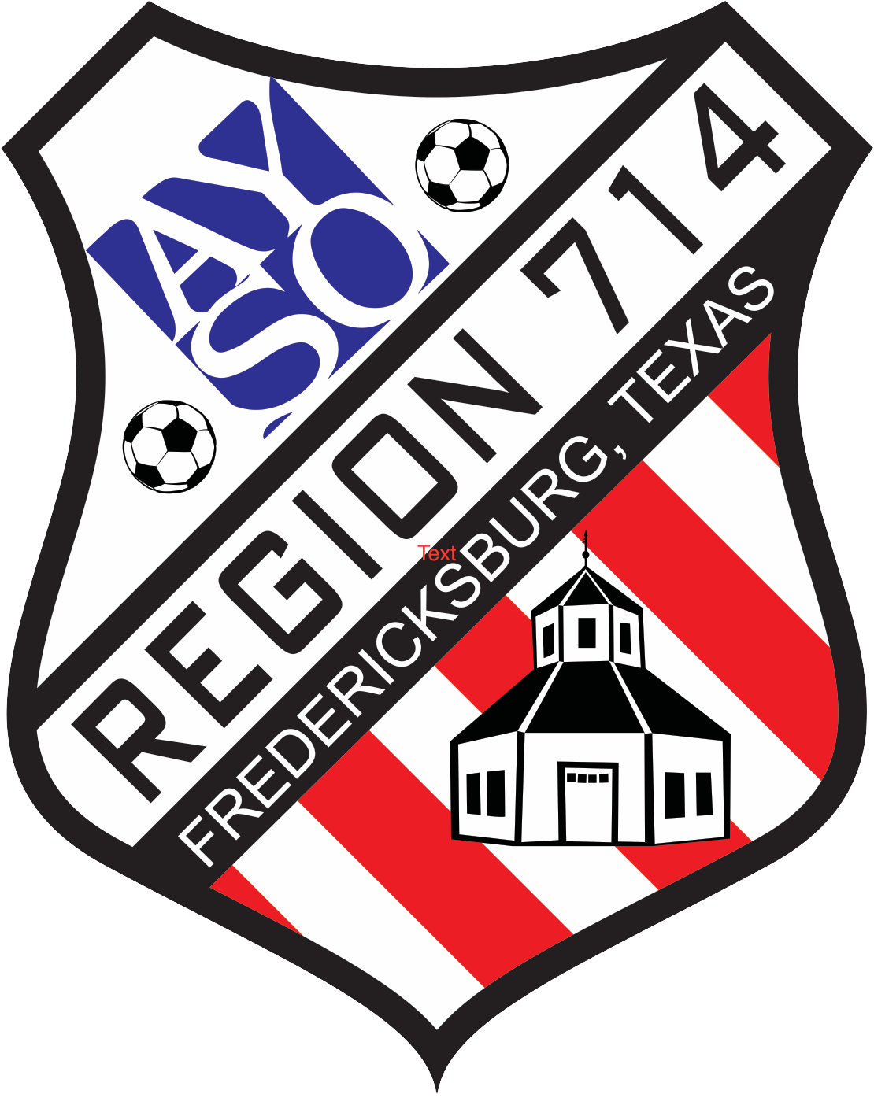
AYSO Region 714 – Fredericksburg, TX
Scholarship Application

Please Print Clearly

- Child’s name: ____________________________________________________________________________
- Has child participated in Region 714 before: Yes / No Year: __________________________________
- Player birth date: _____________________________ Current Age: ____________________________
- Parent/guardian name: ____________________________________________________________________
- Home Phone: ________________________________ Cell Phone: _____________________________
- Reason why your child should be considered for a scholarship*: _____________________________________________________________________________________________________________________________________________________________________________________________________________________________________________________________________
- Is your family currently receiving Government financial aide? Specify: School lunch program? /Other?_______________________________________________________
- Child’s School Name: ______________________________________________________________________
- Would you be able to volunteer in these areas/ways? (circle): - Coaching/Asst. Coach - Field Set up -Refereeing
- Other ________________________________________________________________________________
- Of the $90 registration fee, how much can you pay? $________________________________________
- Parent/ Guardian Signature: ___________________________________ Date: _____________________
* use back or attach additional sheets if needed.
AYSO USE ONLY

Approved: Yes/No Age Division:__________________ Amount Approved: $___________

Comments:____________________________________________________________________

Approved By: ______________________________ Title: _______________________________

Signature: ______________________________________ Date: ________________________

AYSO Region 714 – Fredericksburg, TX
Scholarship Application

The American Youth Soccer Organization (AYSO) is a non-profit, all volunteer program. Our mission is to provide soccer opportunities to as many young athletes as possible in a fun, fair and safe environment.

Our basic policy is that parents/guardians should finance their children’s registration fee to the “extent that they are able.” In that our goal is maximum participation, a scholarship fund has been established in our region to help parents/guardians with the registration fee. An AYSO scholarship is based on financial need of families who are not able to pay for all or part of their child’s registration in order to participate. Because there are limited funds available, the scholarships will go to families who demonstrate the greatest need while scholarship funds remain available.

Criteria:
- Parents/ Guardians must complete the scholarship application form. (Information provided will be held in complete confidence.)
- Families receiving first consideration will be those able to provide documentation that supports the financial need such as proof of current government financial aid or that the child is a participant of a free school lunch program (Title I Student). In addition or as an alternative, AYSO will also give priority consideration to recommendations received from government agencies, social agencies or school administrators (such as school principal).
- Amount and type of previous volunteerism provided by the applicant family or child may improve consideration for a scholarship. Failure to meet previous volunteer commitments or lack of willingness to volunteer will also be a consideration.
- Scholarship applicants should be submitted in person for approval at any regularly scheduled AYSO Region 714 registration event.

Registration Dates:
AYSO Region 714 Registration dates: see registration page at www.fbgtxsoccer.com

